Following information is required for drafting of patent application.

1. **Full name, nationality and address of applicant(s):**

|  |  |  |
| --- | --- | --- |
| **Full Name** | **Nationality** | **Address** |
| Vishwakarma Institute of Technology | Indian | 666, Upper Indiranagar, Bibwewadi, Pune, Maharashtra, India – 411 037 |

1. **Full name (including middle name), nationality, address (VIT/VIIT address), mail id, and phone number of inventor(s):**

|  |  |  |  |  |
| --- | --- | --- | --- | --- |
| **Full Name (Including middle name)** | **Nationality** | **VIT/VIIT Address (Start with full dept. name followed by full institute name)** | **Mail ID** | **Phone No.** |
| Manas Girish Kulkarni | IN | Department of Electronics and Telecommunication Engineering, Vishwakarma Institute of Information Technology, Survey No.3/4, Kondhwa, Budruk, Pune - 411048, Maharashtra, India. | manas.22311608@viit.ac.in | +91 79724 70825 |
| Rajlakshmi Nilesh Desai | IN | Department of Electronics and Telecommunication Engineering, Vishwakarma Institute of Information Technology, Survey No.3/4, Kondhwa, Budruk, Pune - 411048, Maharashtra, India. | rajlakshmi.22311732@viit.ac.in | +91 86057 96792 |
| Samiksha Shailesh Nalawade | IN | Department of Electronics and Telecommunication Engineering, Vishwakarma Institute of Information Technology, Survey No.3/4, Kondhwa, Budruk, Pune - 411048, Maharashtra, India. | samiksha.22311696@viit.ac.in | +91 96041 07070 |
| Dhanashree Uttam Biradar | IN | Department of Electronics and Telecommunication Engineering, Vishwakarma Institute of Information Technology, Survey No.3/4, Kondhwa, Budruk, Pune - 411048, Maharashtra, India. | dhanshree.22420133@viit.ac.in | +91 95790 54664 |
| Dr. Pravin Ganpatrao Gawande | IN | Department of Electronics and Telecommunication Engineering, Vishwakarma Institute of Information Technology, Survey No.3/4, Kondhwa, Budruk, Pune - 411048, Maharashtra, India. | pravin.gawande@viit.ac.in | +91 98502 87681 |
| Dr. Ketan Janraoji Raut | IN | Department of Electronics and Telecommunication Engineering, Vishwakarma Institute of Information Technology, Survey No.3/4, Kondhwa, Budruk, Pune - 411048, Maharashtra, India. | ketan.raut@viit.ac.in | +91 9970 011320 |
| Dr. Minal Samir Deshmukh | IN | Department of Electronics and Telecommunication Engineering, Vishwakarma Institute of Information Technology, Survey No.3/4, Kondhwa, Budruk, Pune - 411048, Maharashtra, India. | minal.deshmukh@viit.ac.in | +91 98500 35005 |

1. **Title of the invention:**

Real-Time Adaptive Temperature Monitoring and Control System for Refrigerated Transport Using Microcontroller

1. **Technical field of the invention:**

The present invention relates to the field of electronic control systems and temperature regulation technologies. More specifically, it pertains to real-time temperature monitoring and adaptive control systems utilizing microcontroller-based architecture, designed for application in refrigerated transport vehicles used in cold chain logistics. The invention integrates sensing, control, and communication components to maintain optimal thermal conditions for perishable goods during transportation.

1. **Prior art:**

Conventional temperature control systems for refrigerated transport vehicles primarily rely on mechanical thermostats, fixed threshold-based microcontrollers, or relay-based ON/OFF switching mechanisms. These systems activate cooling only when the internal temperature crosses a preset limit and deactivate it once the desired level is restored. Examples include:

* Mechanical relay-based controls used in legacy refrigeration systems.
* Basic microcontroller implementations that perform static ON/OFF switching based on preset temperature thresholds (e.g., turn ON at >10°C, OFF at ≤10°C) without consideration of the temperature trend.
* Academic or hobbyist-level designs that use LM35 or DHT11 sensors connected to microcontrollers for basic switching, often lacking dynamic behaviour or real-world deployability.

Disadvantages of existing technologies include:

* Delayed response to rapid temperature changes, which can damage perishable goods.
* Lack of adaptability — systems do not consider how quickly the temperature is rising.
* No energy optimization — fan and cooling elements often run unnecessarily, increasing power consumption.
* No low-power modes — displays and microcontrollers remain fully active even when the environment is stable.
* Non-modular and bulky — typical setups are not optimized for real vehicle environments.

1. **Object:**

The primary object of the present invention is to develop an intelligent, adaptive, and energy-efficient temperature control system for refrigerated transport vehicles using embedded microcontroller technology.

This invention aims to overcome the limitations of traditional fixed-threshold or relay-based systems by introducing predictive control, adaptive cooling response, and smart power management — all integrated into a compact, modular PCB-based design.

Key Advantages Over Existing Technology:

* Pre-emptive Cooling Response: The system predicts rising temperature trends and activates cooling mechanisms before the temperature threshold is breached, ensuring better protection of perishable goods.
* Adaptive Peltier Duty Cycle: Unlike conventional systems with fixed ON/OFF behaviour, the Peltier module in this invention operates with a linearly scaled PWM duty cycle, offering fine-grained control and improved energy efficiency.
* Power Optimization: The OLED display is dynamically turned off during stable conditions, significantly reducing overall power consumption without compromising functionality.
* Compact and Deployable Design: The entire control system is implemented on a custom PCB, making it suitable for integration in space-constrained refrigerated vehicle cabins.
* Software-Defined Logic: All control algorithms are implemented in firmware, allowing easy updates, customizations, and future feature expansions without hardware redesign.

1. **Synopsis:**

The present invention relates to a microcontroller-based adaptive temperature monitoring and control system designed specifically for refrigerated transport vehicles. The invention ensures efficient and responsive thermal management by intelligently adjusting cooling mechanisms based on real-time temperature readings and trends.

Assembly and operation:

All components are interfaced with the microcontroller using analog, digital, and PWM signals, and mounted on a custom-designed PCB. The LM35 sensor continuously feeds temperature data to the microcontroller. Based on this data and the detected trend, the microcontroller adjusts the speed of the fan and the duty cycle of the Peltier module. The OLED display provides user feedback, while the buzzer is triggered when the temperature exceeds the safe threshold. This intelligent, modular design provides reliable, automated thermal control while minimizing energy usage, making it well-suited for cold-chain logistics and mobile refrigeration applications.

1. **Brief description of drawings (if any):**

Figure 1 illustrates the block diagram of the proposed microcontroller-based temperature monitoring and control system for refrigerated vehicles.

Figure 2 shows the complete circuit schematic of the system.

The numerals used to denote the components in the figure are as follows:

* 100 – OLED Display (SSD1306)
* 101 – LM7805 Voltage Regulator
* 102 – L293D Motor Driver IC with 2 12V DC Fans
* 103 – ATmega328P Microcontroller
* 104 – Peltier Cooling Module (TEC1-12706)
* 105 – LM35 Temperature Sensor
* 106 – Buzzer (Overheat Alert)

Figure 3 provides a 3D view of the custom-designed PCB used in the system.

Figure 4 shows the side view of the assembled PCB layout.

Figure 5 presents the track layout of the PCB.

Figure 6 depicts the exterior view of the system enclosure from the top.

Figure 7 shows the exterior view from the back, highlighting the fan and heat sink placement.

Figure 8 presents the interior view, showing component integration and wiring inside the enclosure.

1. **Detailed description of the invention:**

The present invention discloses a microcontroller-based adaptive temperature control and monitoring system tailored for refrigerated transport vehicles. It offers an embedded solution for maintaining internal temperatures close to 10°C, using real-time feedback and intelligent control algorithms to prevent thermal degradation of perishable goods. The system is built on the ATmega328P microcontroller and integrates temperature sensing, active cooling, visual feedback, and audio alerts on a custom-designed PCB.

***Core Components:***

* LM35 Analog Temperature Sensor: Provides real-time temperature readings with 10mV/°C linearity.
* ATmega328P Microcontroller: Processes temperature data, performs logic-based decision making, and controls output peripherals.
* Peltier Module (TEC1-12706): Offers thermoelectric cooling using a PWM-driven signal.
* DC Fans (12V): Dissipate heat from the Peltier module and circulate air inside the chamber.
* OLED Display (SSD1306): Visually displays temperature, fan speed, and Peltier duty cycle.
* Buzzer: Alerts when internal temperature exceeds a defined threshold.
* L293D Motor Driver: Drives the dual fans, ensuring electrical isolation between control and power circuits.
* Custom Printed Circuit Board (PCB): Hosts all components in a modular and vehicle-deployable format.

***Functional Description:***

* 1. **Temperature Monitoring**

The LM35 sensor, placed within the refrigerated compartment, outputs analog voltage proportional to temperature. This is read through the ATmega328P’s 10-bit ADC. The system calculates the actual temperature using a linear conversion formula. Measurements are taken continuously to ensure immediate response to thermal changes.

* 1. **Data Processing and Control Logic**

The firmware processes temperature readings and compares them with previous values to determine the rate of change (temperature trend). Based on this, the system applies the following logic:

* If temperature is below or equal to 10°C and stable, all cooling elements remain off.
* If the temperature is rising rapidly (≥2°C within 0.5s), preemptive cooling is triggered even if the value is below 10°C.
* Above 10°C, fan speed and Peltier duty are scaled based on temperature, as described below.
  1. **Adaptive Cooling Mechanism**

The fan and Peltier module operate under adaptive control:

* Fan Speed: Scaled in steps of 25%, 50%, 75%, and 100% depending on the current temperature.
* Peltier Duty Cycle: Linearly mapped between 0% (at 10°C) and 100% (at 18°C), offering smooth control and reducing power spikes.
  1. **Alert System**

A buzzer is triggered whenever the temperature exceeds 11°C. The buzzer alerts at 2-second intervals to avoid continuous sound while ensuring attention.

* 1. **OLED Display**

The system uses a 0.96-inch SSD1306 OLED display to show:

* Current temperature (in °C)
* Fan speed percentage
* Peltier duty cycle

To optimize power, a display sleep mode is implemented. If temperature remains unchanged for more than 5 seconds, the display turns off automatically and resumes upon detecting a change in temperature.

**Implementation and Testing:**

The system was implemented on a compact custom PCB and tested inside a refrigerated enclosure. Under various thermal load conditions:

* The pre-emptive logic activated cooling before temperature breach, reducing overshoot.
* The adaptive Peltier control reduced current draw compared to fixed ON/OFF switching.
* The OLED sleep mode reduced unnecessary display power during steady-state conditions.

Power was supplied using a 12V DC source. Firmware was developed in Embedded C and flashed using USBasp via SPI.

* ***Power Consumption:***

LM35 Temperature Sensor:

ATmega328P Microcontroller:

OLED I2C Display:

Buzzer:

IRLZ44N MOSFET (Gate control only):

L293D Motor Driver (Logic power only):

Internal Fan (Air Circulation):

External Fan (Heatsink):

Peltier Module (TEC1-12706):

* ***Total Power Consumption:***

At 5V side (through 7805):

At 12V side (direct):

Total Power:

* **Current Draw from 12V Adapter:**

Components powered through the 7805 (5V side) draw more current from the adapter due to voltage drop and inefficiency (linear regulation):

So, the total 12V current draw from the adapter is:

1. **Best method of performance of the invention:**

The invention is best performed by integrating all components on a custom-designed PCB and placing the LM35 temperature sensor within the refrigerated vehicle's cargo space. The ATmega328P microcontroller is programmed with embedded C code to continuously monitor temperature via its ADC input. Upon power-up, the microcontroller initializes all peripherals including the OLED display (I2C), PWM for the fan and Peltier module, and GPIO for the buzzer.

In actual working conditions, when the temperature begins to rise, the system analyses not just the current temperature but also the rate at which it is changing. If the system detects a rapid increase in temperature, it pre-emptively starts the cooling mechanism—activating the DC fans and the Peltier module proportionally. For example, if the temperature rises from 9.5°C to 11°C rapidly, the fan speed is set to 50% or more and the Peltier duty cycle is scaled up accordingly. The OLED displays the current status in real time, while the buzzer activates if the temperature crosses 11°C.

When the temperature stabilizes around 10°C and remains constant over multiple readings, the system automatically powers down the OLED display to conserve energy. This method of operation has been tested under controlled environmental conditions and shown to maintain the desired temperature range efficiently, while reducing power consumption and increasing the responsiveness of the system.

1. **CLAIMS:**

* **A microcontroller-based temperature control system** for refrigerated transport vehicles comprising a temperature sensor, cooling module, fan assembly, and a microcontroller, wherein the system monitors temperature and controls cooling operations based on both current temperature values and the rate of temperature change.
* **A pre-emptive cooling control method** implemented in the system as claimed in claim 1, wherein the microcontroller initiates cooling operations when a rapid increase in temperature is detected, even before exceeding a pre-set threshold.
* **An adaptive Peltier control mechanism** wherein the microcontroller calculates and applies a linearly scaled PWM duty cycle to the Peltier module based on real-time temperature values ranging between a lower limit and an upper limit, thus optimizing energy consumption and thermal regulation.
* **A power-saving display control system** wherein the OLED display is automatically turned off during stable temperature conditions and reactivated upon detecting a change in temperature, thereby reducing power usage.
* **An integrated control circuit on a custom-designed printed circuit board (PCB)** that houses the microcontroller, sensor, actuators, display, and alert system, enabling modular, compact, and vehicle-ready deployment of the complete temperature control system.
* **A buzzer alert mechanism** activated when the internal temperature crosses a predefined safety threshold, providing an audible warning in addition to visual feedback.
* **A modular embedded system** wherein all control algorithms are software-defined and can be updated without modifying the hardware, allowing for reconfigurability and future enhancements.

1. **Inventive step of your invention:**

The inventive step of the present invention lies in its ability to intelligently predict and respond to temperature changes, rather than relying solely on static threshold-based switching, which is common in existing refrigerated control systems. The invention integrates a pre-emptive control algorithm that initiates cooling actions based on the rate of temperature rise, thereby maintaining thermal stability more efficiently.

Unlike conventional systems that operate fans and cooling elements using fixed ON/OFF logic, this system introduces a linearly scaled PWM control for the Peltier module, which adapts in real-time to varying thermal loads. This results in improved energy efficiency, reduced thermal shock, and longer operational lifespan of the cooling components.

Another significant inventive feature is the OLED display power-saving logic, which automatically turns off the display when temperature readings remain stable, significantly reducing unnecessary power consumption. This is especially advantageous in mobile and battery-powered refrigerated applications.

All these functions are implemented in software on a compact, microcontroller-based PCB, offering a low-cost and upgradable alternative to more complex and expensive industrial refrigeration controllers.

Thus, the invention achieves a clear technical advantage over the prior art by combining predictive logic, adaptive control, and power-saving mechanisms in a unified, deployable platform—resulting in smarter performance, lower energy usage, and reduced system complexity.

1. **Industrial application:**

The present invention finds application in the field of cold chain logistics, particularly in the transportation of temperature-sensitive goods such as food, pharmaceuticals, vaccines, biological samples, and dairy products. It is specifically suited for use in refrigerated trucks, vans, and mobile cold storage units where maintaining a consistent internal temperature is critical to preserving product integrity.

The invention can also be adapted for use in portable medical coolers, mobile diagnostic labs, and last-mile vaccine delivery systems, especially in rural and power-constrained areas where energy efficiency and reliability are essential. Due to its modular and compact design, it can be deployed in fleet-based cold transport systems, enabling centralized monitoring and upgrading of distributed vehicles.

Its adaptability, energy efficiency, and software-defined logic make it particularly beneficial in industries aiming to improve thermal management, reduce power costs, and enhance automation in refrigerated transportation.

1. **Abstract:**

The present invention relates to a microcontroller-based temperature monitoring and control system designed for refrigerated transport vehicles. It employs an LM35 temperature sensor, DC fans, a thermoelectric Peltier module, and an OLED display, all integrated on a compact printed circuit board controlled by an ATmega328P microcontroller. The system introduces intelligent software features including preemptive cooling based on temperature trend analysis, adaptive PWM control for efficient energy use, and an automatic OLED display sleep function for power saving. The invention ensures consistent internal temperature, improves cooling responsiveness, reduces power consumption, and is ideally suited for cold chain logistics and mobile refrigeration applications.

1. **Drawings**

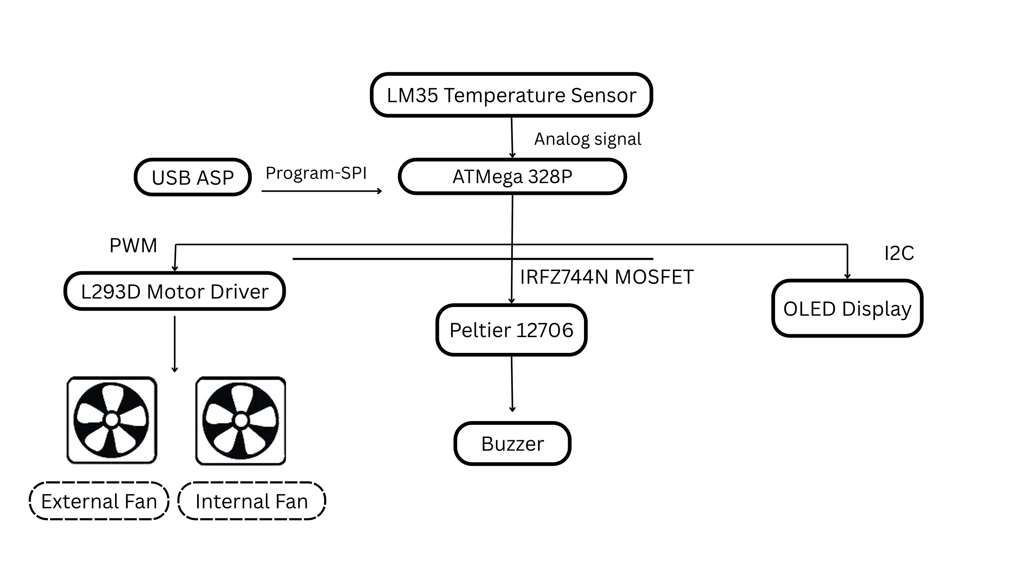

**Figure 1**

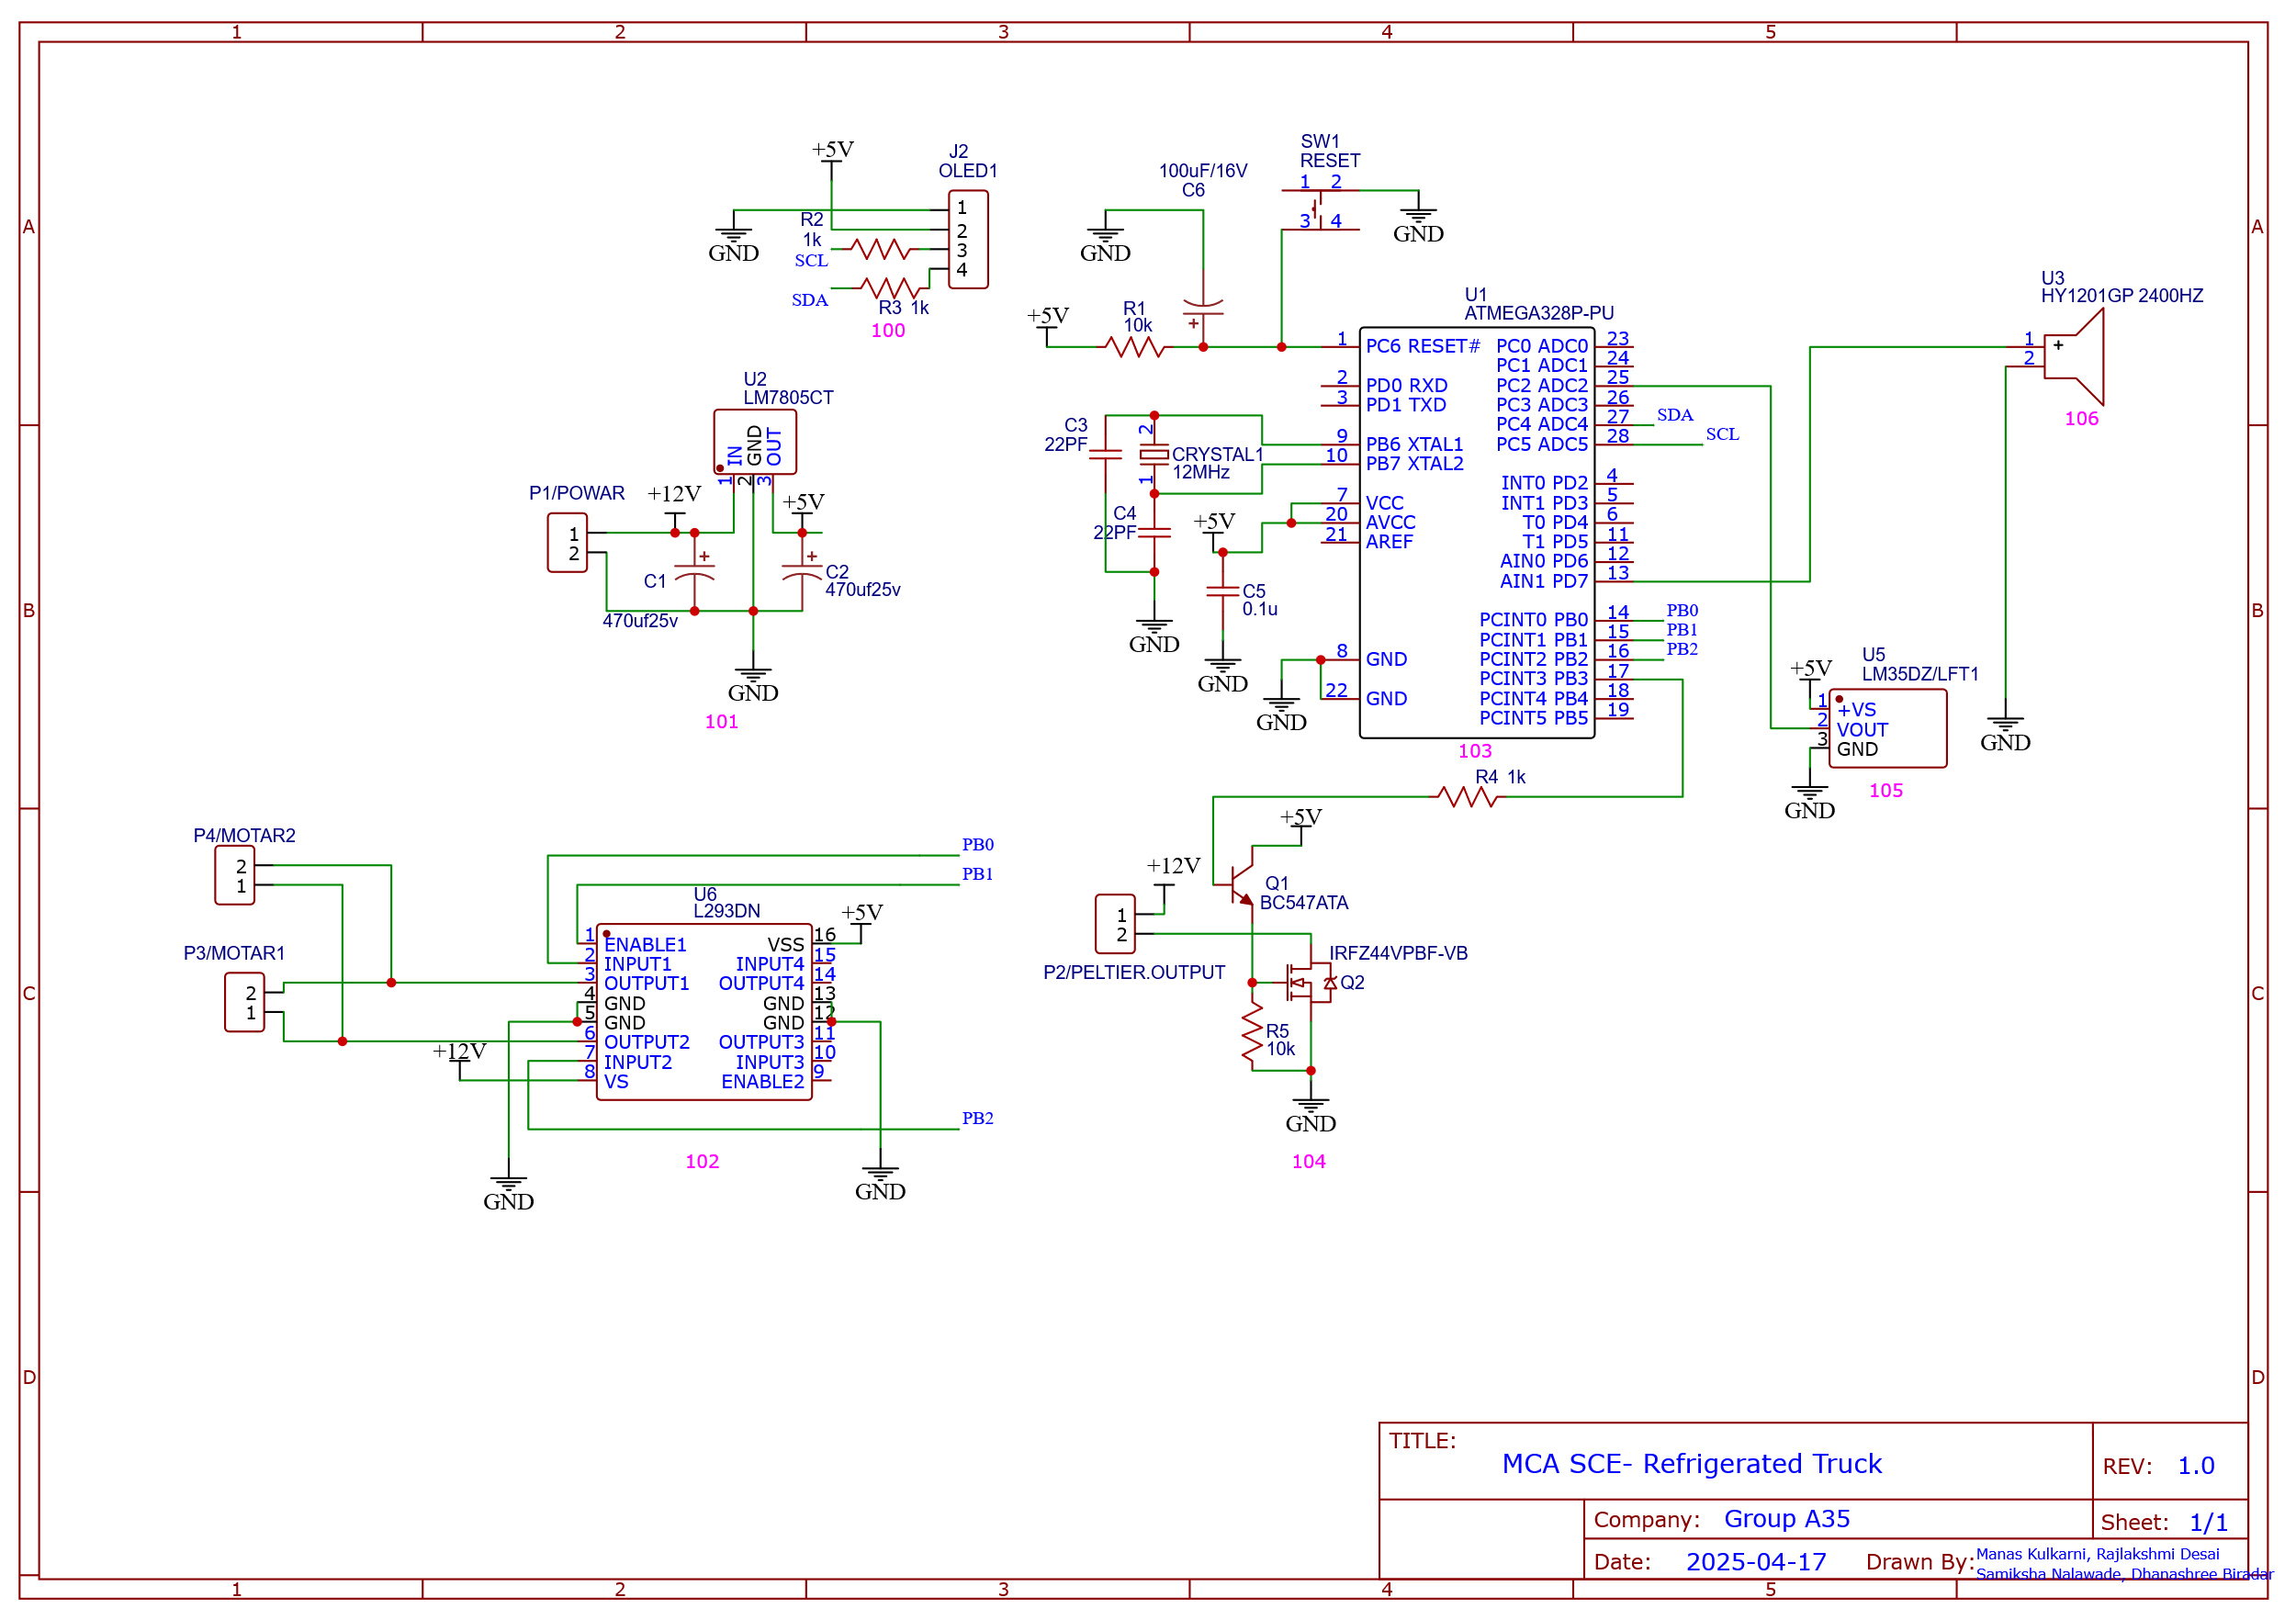

**Figure 2**

**Figure 3**

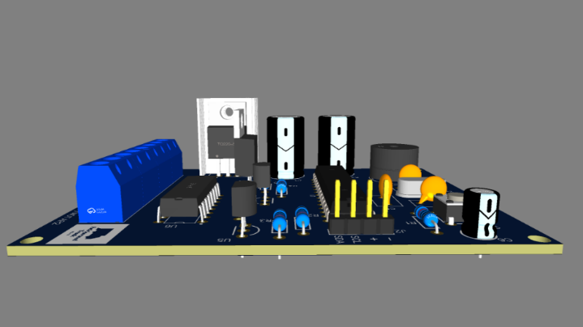

**Figure 4**

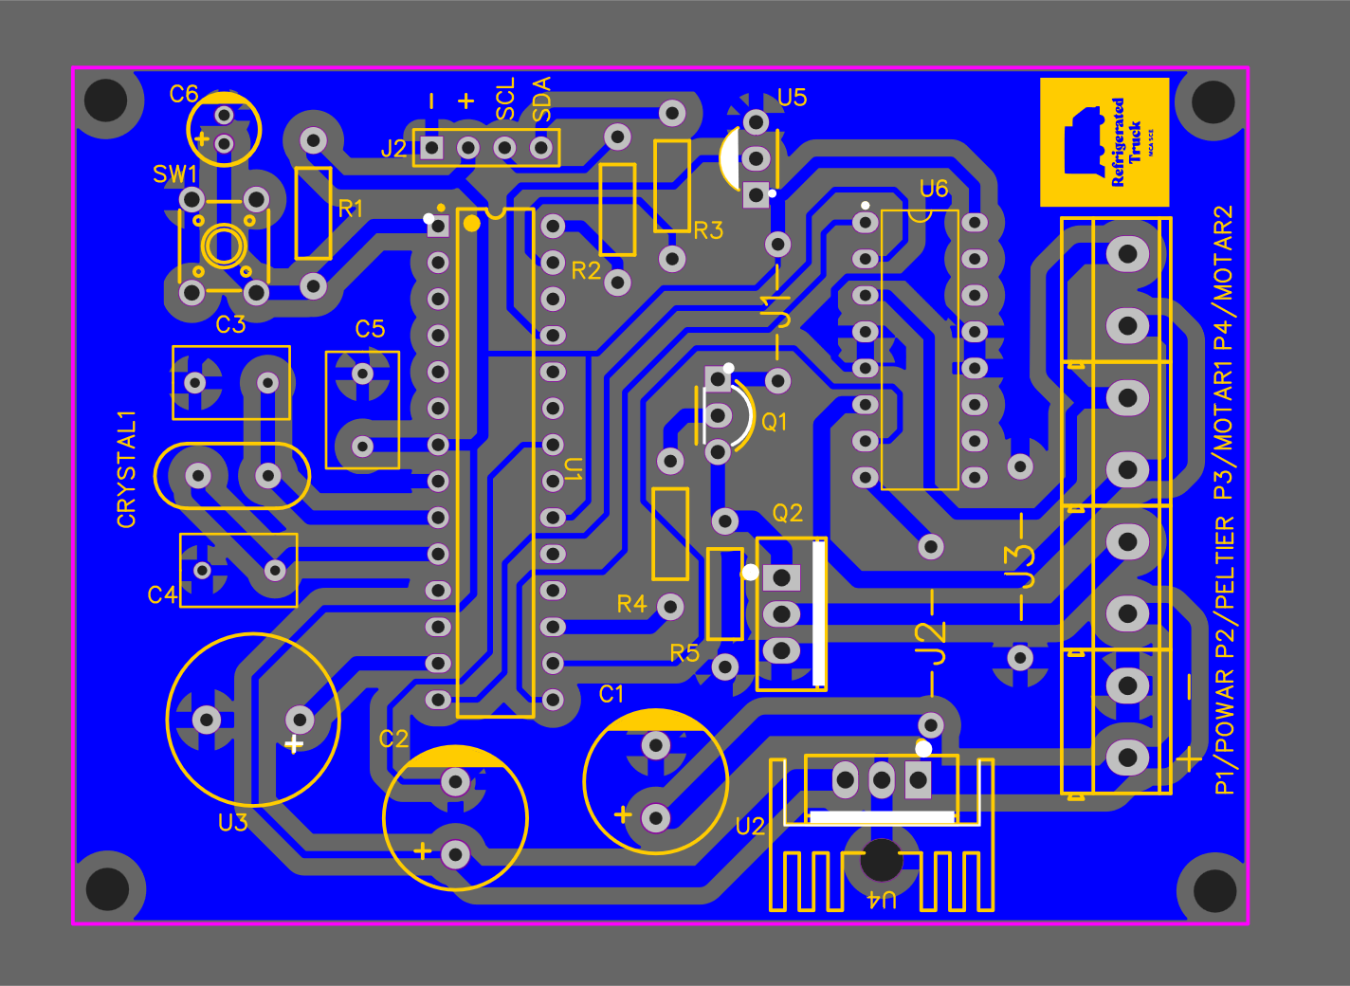

**Figure 5**



**Figure 6**

**Figure 7**

**Figure 8**

1. **Bill of Materials**

|  |  |  |  |  |  |
| --- | --- | --- | --- | --- | --- |
| ID | Name | Designator | Footprint | Quantity | Pins |
| 1 | 1000uf25v | C1 | CAP-D10.0×F5.0 | 1 | 2 |
| 2 | 470uf16v | C2 | CAP-D10.0×F5.0 | 1 | 2 |
| 3 | 22PF | C3,C4 | RAD-0.2 | 2 | 2 |
| 4 | 0.1u | C5 | RAD-0.2 | 1 | 2 |
| 5 | 100uF/16V | C6 | CAP-D5.0×F2.0 | 1 | 2 |
| 6 | 12MHz | CRYSTAL1 | CRYSTAL-TH_L10.8-W4.5-P4.88 | 1 | 2 |
| 7 | OLED1 | J2 | HDR-M-2.54_1X4 | 1 | 4 |
| 8 | CONN-TH_2P-P5.00 | P1/POWAR,P2/PELTIER,P3/MOTAR1,P4/MOTAR2 | CONN-TH_2P-P5.00 | 4 | 2 |
| 9 | BC547ATA | Q1 | TO-92-3_L4.9-W3.7-P2.54-L | 1 | 3 |
| 10 | IRFZ44VPBF-VB | Q2 | TO-220-3_L10.0-W4.5-P2.54-L | 1 | 3 |
| 11 | 10k | R1,R5 | R_AXIAL-0.4 | 2 | 2 |
| 12 | 1k | R2,R3,R4 | R_AXIAL-0.4 | 3 | 2 |
| 13 | RESET | SW1 | KEY-TH_4P-L6.2-W6.2-P4.50-LS6.5 | 1 | 4 |
| 14 | ATMEGA328P-PU | U1 | DIP-28_L34.6-W7.3-P2.54-LS10.2-BL | 1 | 28 |
| 15 | LM7805CT | U2 | TO-220-3_L10.0-W4.5-P2.54-L | 1 | 3 |
| 16 | HY1201GP 2400HZ | U3 | BUZ-TH_BD12.0-P6.50-D0.6-FD | 1 | 2 |
| 17 | LM35DZ/LFT1 | U5 | TO-92-3_L4.8-W3.7-P2.54-L | 1 | 3 |
| 18 | L293DN | U6 | DIP-16_L19.2-W6.6-P2.54-LS7.6-BL | 1 | 16 |
| 19 | SINK-TH_L15.0-W10.5-H21.0 | U4 | SINK-TH_L15.0-W10.5-H21.0 | 1 | 1 |